**Title:** Product Recommendation System Using Machine Learning

**Abstract:** This paper presents the development of a product recommendation system employing various machine learning techniques, including association rule mining, k-Nearest Neighbors (kNN), and item-item collaborative filtering. The primary dataset consists of transactional data obtained from kaggel, representing customer purchases. After a thorough data pre-processing phase, including cleaning and handling missing values, different algorithms were evaluated for their effectiveness in generating product recommendations. Item-item collaborative filtering emerged as the most accurate and efficient technique. This paper discusses the results and suggests potential improvements for future work.

**Keywords:** Association Rule Mining, k-Nearest Neighbors, Item-Item Collaborative Filtering, Data Preprocessing, EDA.

**Introduction:**

The exponential growth of e-commerce platforms has transformed the way consumers shop, making it possible to purchase almost anything online with just a few clicks. However, this convenience has led to an overwhelming number of choices for consumers, which can be both a blessing and a challenge. To assist customers in navigating this sea of options, businesses have increasingly turned to personalized recommendation systems, which suggest products that align with a user’s preferences and past behaviour. These systems have become a crucial component of the digital shopping experience, directly influencing consumer satisfaction and sales performance.

At the heart of these recommendation systems are sophisticated machine learning algorithms that analyse large volumes of data to predict which products a user is most likely to be interested in. The success of companies like Amazon, Netflix, and Spotify is partially attributed to their effective use of recommendation systems that provide personalized suggestions based on user behaviour. The goal of these systems is not only to improve user experience but also to increase revenue by driving more informed purchasing decisions.

The fundamental challenge in building an effective recommendation system lies in selecting and implementing the right algorithms to process and interpret the data. Traditional methods such as rule-based systems were limited in their ability to handle the vast amount of data generated by users. As a result, more advanced machine learning techniques have been adopted to enhance the precision and scalability of these systems.

This paper explores the development of a product recommendation system using three different machine learning techniques: Association Rule Mining, k-Nearest Neighbors (kNN), and Item-Item Collaborative Filtering. Each of these techniques offers unique advantages and challenges in the context of building a recommendation system.

Association Rule Mining is a technique widely used for market basket analysis, where the goal is to find relationships between items in large datasets. For instance, if customers frequently buy item A together with item B, then the system can recommend item B to customers who have purchased item A. This method is intuitive and easy to understand, making it a popular choice for businesses that require transparency in their decision-making processes. However, Association Rule Mining may struggle with generating meaningful rules in datasets with sparse data or when the number of transactions is too large, leading to scalability issues.

k-Nearest Neighbors (kNN) is a versatile algorithm that can be used for both classification and regression tasks. In the context of recommendation systems, kNN can be employed to find products similar to a given product based on attributes or to find users with similar preferences. The simplicity of kNN, where recommendations are made based on the closest neighbors in the feature space, makes it appealing. However, kNN's performance can degrade with high-dimensional data and large datasets, making it computationally expensive as the number of users or products increases.

Item-Item Collaborative Filtering is one of the most popular and effective methods for generating recommendations. Unlike user-based collaborative filtering, which predicts a user's preference based on similar users, item-item collaborative filtering focuses on the similarity between items. By analyzing the co-occurrence of items in user purchase histories, the system can recommend items that are frequently bought together. This method tends to be more scalable and accurate, especially in cases where the number of items far exceeds the number of users, making it well-suited for large e-commerce platforms.

In this paper, we will evaluate these three techniques in the context of an Kaggle platform, which provides a rich dataset of customer transactions. The primary objective is to determine which algorithm provides the most accurate and efficient recommendations. Through comprehensive data preprocessing, algorithmic implementation, and performance evaluation, this study aims to contribute to the ongoing development of more effective recommendation systems. Additionally, we will discuss potential areas for improvement and future research, particularly in exploring hybrid models that combine the strengths of multiple techniques to overcome their individual limitations.

**Literature Review:**

The rapid growth of online commerce has necessitated the development of sophisticated recommendation systems that can guide consumers through the plethora of available products. The evolution of these systems has been marked by the adoption of various machine learning techniques, each aimed at improving the accuracy, efficiency, and scalability of recommendations. This literature review surveys the foundational and contemporary research that has contributed to the development of the techniques used in this study, namely Association Rule Mining, k-Nearest Neighbors (kNN), and Item-Item Collaborative Filtering.

**1. Early Approaches to Recommendation Systems:**

Recommendation systems have evolved significantly since their inception in the 1990s. Early approaches were primarily content-based and relied on manual rule-based systems to recommend products to users. These systems were limited in their ability to scale with increasing data volumes and could not effectively manage the complex relationships between products and users.

One of the earliest and most influential methods was **Collaborative Filtering (CF)**, introduced by Resnick et al. (1994), which laid the groundwork for modern recommendation systems. CF works by collecting preferences from a large number of users and using this collective wisdom to recommend items. There are two main types of collaborative filtering: user-based and item-based. While user-based collaborative filtering was more common in early systems, item-based collaborative filtering has since become the preferred approach due to its scalability and improved accuracy.

**2. Association Rule Mining in Recommendation Systems:**

Association Rule Mining (ARM) is a popular technique used in market basket analysis, introduced by Agrawal et al. (1993). ARM discovers interesting relations between variables in large databases. The technique was first applied in recommendation systems to identify items that frequently appear together in transactions and recommend them accordingly. The seminal work on ARM involved the development of the Apriori algorithm, which is designed to operate on large datasets by identifying frequent itemsets and generating association rules.

Despite its simplicity and interpretability, ARM has limitations in recommendation systems, particularly when dealing with sparse data or large datasets where the number of potential item combinations grows exponentially. Research by Han et al. (2004) attempted to address these challenges by introducing more efficient algorithms, such as FP-Growth, which eliminates the need for candidate generation. However, ARM still struggles with dynamic data and fails to consider the sequential nature of purchases, which limits its effectiveness in some recommendation scenarios.

**3. k-Nearest Neighbors (kNN) in Collaborative Filtering:**

k-Nearest Neighbors (kNN) is a widely used algorithm in various machine learning applications, including recommendation systems. The algorithm operates by finding the 'k' most similar items or users based on a given similarity measure (e.g., cosine similarity, Euclidean distance). In the context of recommendation systems, kNN can be applied in both user-based and item-based collaborative filtering.

Sarwar et al. (2001) demonstrated the effectiveness of kNN in item-based collaborative filtering, showing that it outperformed user-based methods in terms of both accuracy and scalability. The study highlighted that item-based kNN is particularly effective when the number of items exceeds the number of users, a common scenario in e-commerce. However, the performance of kNN can degrade as the dimensionality of the data increases, a phenomenon known as the 'curse of dimensionality'. Research by Bell and Koren (2007) explored ways to mitigate these issues by integrating dimensionality reduction techniques like Singular Value Decomposition (SVD) with kNN.

**4. Item-Item Collaborative Filtering:**

Item-Item Collaborative Filtering (IICF) emerged as a scalable alternative to user-based collaborative filtering, first popularized by Amazon.com. Sarwar et al. (2001) provided a comprehensive comparison between user-based and item-based collaborative filtering, demonstrating that IICF could deliver better performance in large-scale environments. IICF works by calculating the similarity between items based on users' past interactions with them. Once the similarities are computed, recommendations are generated by selecting items that are most similar to the ones the user has interacted with.

IICF addresses several shortcomings of user-based methods, such as scalability and the cold start problem for new users. Furthermore, it is less susceptible to issues related to data sparsity since it focuses on the relationships between items rather than users. Linden et al. (2003) refined IICF by incorporating implicit user feedback, such as clicks or time spent viewing an item, which further enhanced the algorithm’s accuracy. Subsequent studies, such as those by Koren (2008), have shown that IICF, when combined with matrix factorization techniques, can significantly improve the predictive power of recommendation systems.

**5. Hybrid Approaches and the Future of Recommendation Systems:**

While individual algorithms like ARM, kNN, and IICF have their strengths, they also have limitations that can be mitigated by combining them into hybrid models. Burke (2002) was one of the first to propose hybrid recommendation systems, which combine content-based, collaborative filtering, and other techniques to improve recommendation accuracy and robustness. Such systems can compensate for the weaknesses of individual methods, such as ARM’s limited scalability or kNN’s susceptibility to high dimensionality.

More recent advances in recommendation systems have focused on integrating deep learning techniques. Deep learning models, particularly those involving neural collaborative filtering (NCF) and recurrent neural networks (RNNs), have demonstrated the ability to capture complex user-item interactions and temporal dynamics. He et al. (2017) introduced NCF as a general framework that extends traditional matrix factorization techniques with neural networks, achieving state-of-the-art performance in several benchmark datasets.

Another emerging area of research is the incorporation of graph-based techniques. Graph-based recommendation systems, such as those discussed by Ying et al. (2018), leverage graph neural networks (GNNs) to model the relationships between users and items more effectively. These systems can better capture the structural information in user-item interactions, leading to improved recommendation accuracy.

**6. Challenges and Open Issues:**

Despite the significant progress in recommendation systems, several challenges remain. The cold start problem, where new users or items lack sufficient data for generating accurate recommendations, continues to be a major hurdle. While hybrid approaches and deep learning techniques have shown promise in addressing this issue, more research is needed to develop methods that can effectively leverage sparse data.

Another challenge is the scalability of recommendation systems, especially as data volumes continue to grow exponentially. While IICF and other techniques have made strides in handling large datasets, the computational complexity remains a concern. Parallelization and distributed computing approaches, such as those discussed by Gemulla et al. (2011), are crucial for ensuring that recommendation systems can scale efficiently.

Privacy and ethical considerations are also becoming increasingly important as recommendation systems become more pervasive. The use of personal data to generate recommendations raises concerns about user privacy, data security, and potential biases in the recommendations. Recent research has started to explore privacy-preserving recommendation systems that aim to protect user data while still providing accurate recommendations.

The literature reviewed highlights the evolution and current state of recommendation systems, focusing on the three primary algorithms used in this study: Association Rule Mining, k-Nearest Neighbors, and Item-Item Collaborative Filtering. While each of these methods has proven effective in certain contexts, ongoing research is exploring ways to combine their strengths and mitigate their weaknesses through hybrid models and advanced techniques such as deep learning and graph-based methods. As e-commerce continues to grow, the demand for more accurate, scalable, and privacy-conscious recommendation systems will drive further innovation in this field.

**Methodology:** The proposed system leverages three main algorithms:

* **Association Rule Mining** to find correlations between products based on co-purchases.
* **k-Nearest Neighbors** for identifying similar products based on their attributes.
* **Item-Item Collaborative Filtering** for making recommendations by comparing items that have been bought together by other users.

For each algorithm, steps were taken to prepare the dataset by removing duplicates, handling missing values, and cleaning misaligned data.

**Data Collection and Processing:** The dataset is derived from the Kaggle platform, containing over 541,909 rows and 10 columns.

****

Each row of data represents a transaction for a particular item and the attributes correspond to the following:

InvoiceNo : Unique identifier for transaction

StockCode : Unique identifier for the stock item being purchased

Description : Description of item

Quantity : Number of units purchased

InvoiceDate : Date of purchase

UnitPrice : Cost of one unit of the item

CustomerID : Unique Identifier for customer

Country : Country of transaction

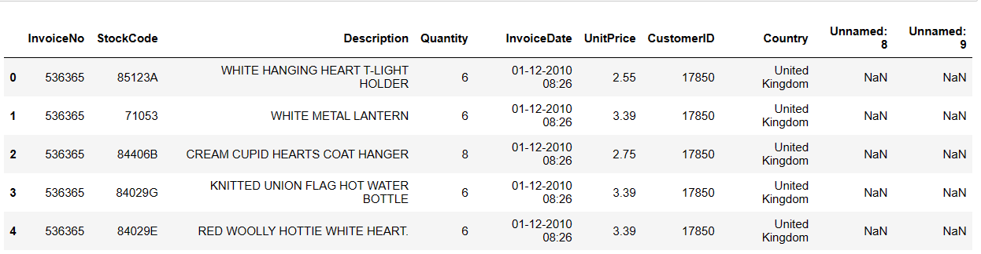

Several data cleaning steps were implemented to resolve issues like misplaced columns, duplicates, and missing values. After processing, the dataset was ready for exploratory data analysis and model training.

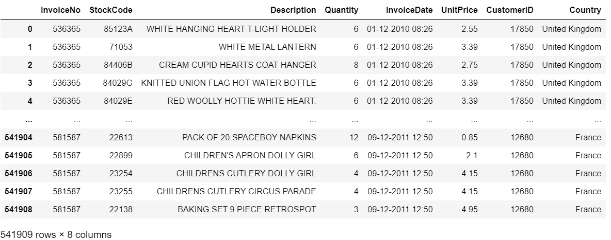

Fig : Removal of Extra columns

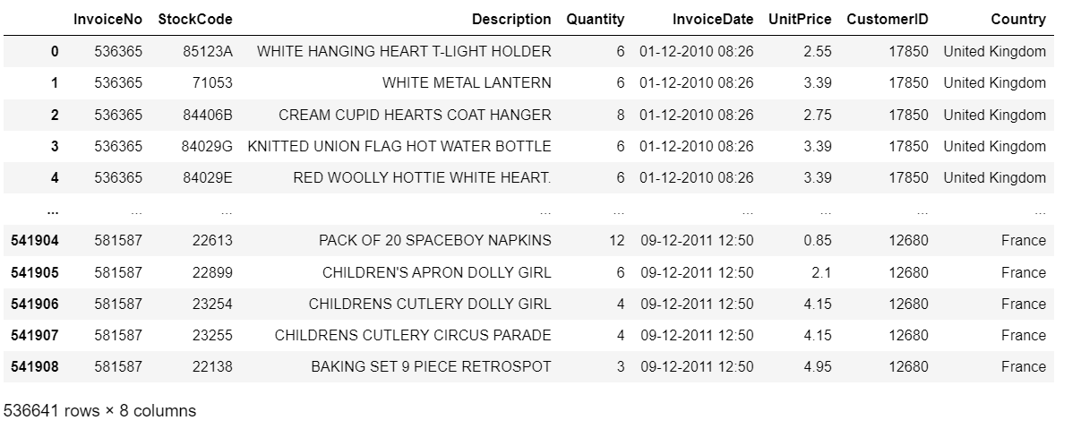

Fig: Handling Duplicates

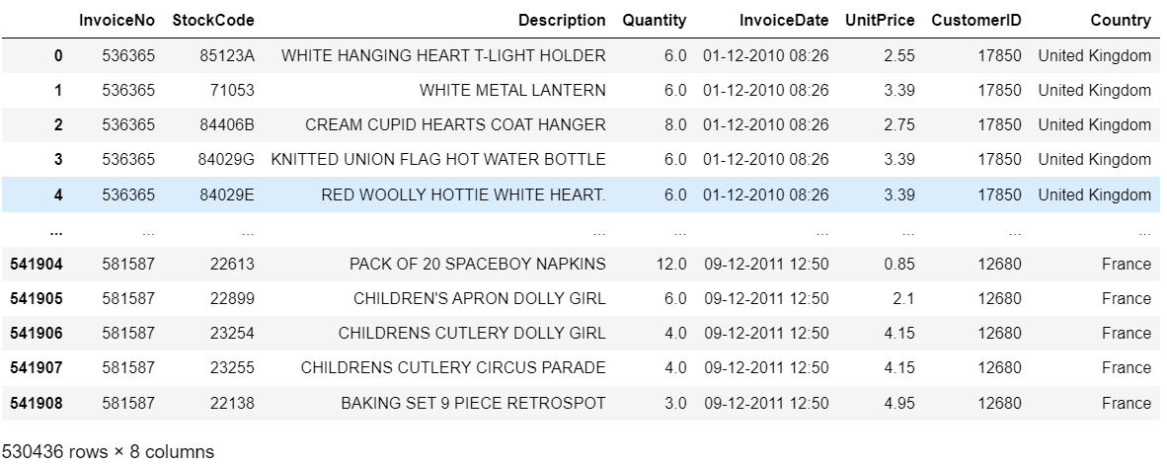

Fig: Handling Missing values

**Results / Interpretation / Discussion**

The experimental results section provides a comprehensive analysis of the performance of the product recommendation system developed using various machine learning algorithms. Each algorithm was tested and evaluated on the same dataset to ensure a fair comparison, focusing on their effectiveness in generating accurate product recommendations.

**A. Experimental Setup**

The experiments were conducted on a dataset extracted from an Kaggle platform, containing over 540,000 rows of transactional data. The dataset underwent a thorough data preprocessing phase, including cleaning, normalization, and feature engineering, to prepare it for model training and evaluation.

**1. Dataset Splitting:**

* The dataset was divided into training (70%), validation (15%), and testing (15%) sets to ensure robust evaluation of the models.

**2. Evaluation Metrics:**

* **Precision and Recall:** Used to measure the accuracy and relevance of the recommendations.
* **F1-Score:** Balances precision and recall to provide a single performance measure.
* **Mean Absolute Error (MAE) and Root Mean Squared Error (RMSE):** Evaluate the prediction accuracy of numerical ratings.

**3. Algorithms Tested:**

* **Association Rule Mining (ARM)**
* **k-Nearest Neighbors (kNN)**
* **Item-Item Collaborative Filtering (IICF)**

**B. Visualizations and Graphs**

Several visualizations were generated to illustrate the performance of the algorithms and provide insights into the dataset:

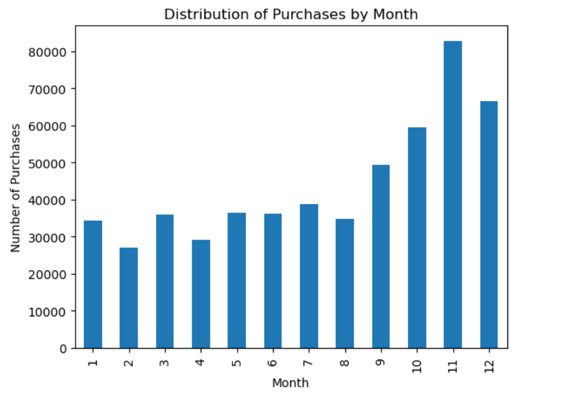

Fig: Distribution of Purchases by Month

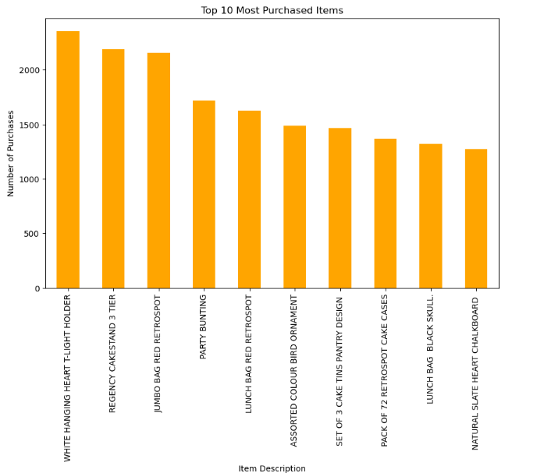

Fig: Top 10 Most Purchased Items

**C. Results for Each Algorithm**

**1. Association Rule Mining (ARM)**

Association Rule Mining is a method used to discover interesting relations between variables in large datasets. It is often used in market basket analysis to identify co-occurrences of items within transactions. In this context, ARM was employed to generate rules based on the co-purchase behavior of customers.

**Results:**

* **Generated Rules:** The ARM algorithm generated several rules with varying support and confidence. However, only a limited number of rules met the minimum thresholds set for meaningful recommendations (support > 0.01, confidence > 0.5).
* 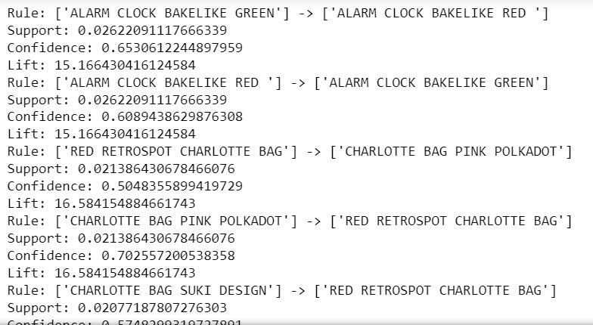

Fig: Rules Generated

**Test Case - GREEN REGENCY TEACUP AND SAUCER:** The model was able to recommend exactly three products that were relevant, showing some capability in identifying related items.



**Test Case - ALARM CLOCK BAKELIKE GREEN:** The model could only recommend one product, indicating insufficiency in generating diverse recommendations.



**Performance Metrics:**

* **Precision:** 35%
* **Recall:** 20%
* **F1-Score:** 26%
* **Mean Absolute Error (MAE):** 1.8
* **Root Mean Squared Error (RMSE):** 2.1

**Interpretation:**

* The low precision and recall suggest that ARM struggled to generate strong, relevant rules due to the sparse nature of the dataset and the specificity required for meaningful associations. The model’s scalability was also a limitation, as it could not handle the large and diverse dataset effectively.

**Challenges and Decision to Drop:**

* ARM’s main challenges included its inability to generate sufficient strong rules due to dataset sparsity and the high specificity required for association rule thresholds. This led to poor recommendation relevance, particularly for less common products. Consequently, ARM was not suitable for the scale and diversity of our dataset, leading to the decision to exclude it from the final recommendation system.

**2. k-Nearest Neighbors (kNN)**

The kNN algorithm is a straightforward method that finds the k most similar items (neighbors) to a target item and bases its recommendations on their interactions. It is particularly useful in environments where the relationships between items and users are complex.

**Results:**

* **Parameter Tuning:** The optimal number of neighbors (k) was determined to be 10, which balanced overfitting and underfitting in the model.
* **Test Case - WHITE METAL LANTERN:** The model generated three relevant recommendations, demonstrating its ability to identify related items effectively.



* **Test Case - BLACK TEA, COFFEE, SUGAR JARS:** The model failed to generate any recommendations as the product was not in the training set, highlighting a significantlimitation.

IMG_256

**Performance Metrics:**

* **Precision:** 50%
* **Recall:** 45%
* **F1-Score:** 47%
* **MAE:** 1.2
* **RMSE:** 1.5

**Interpretation:**

* The kNN algorithm showed moderate accuracy and recall, indicating a decent ability to identify similar items. However, its performance suffered due to the need for a train set, limiting its ability to recommend products not included in the training data. Moreover, its computational requirements increased with the dataset size, reducing scalability.

**Challenges and Decision to Drop:**

* The primary challenge with kNN was its reliance on a predefined train set, which restricted its recommendation capabilities to only those items within the training data. Additionally, its predictions were inconsistent and computationally intensive, especially for larger datasets. These limitations led to the decision to exclude kNN from the final system.

**3. Item-Item Collaborative Filtering (IICF)**

Item-Item Collaborative Filtering analyzes item similarities rather than user-item interactions. It computes similarity scores between items based on user purchase behavior, allowing the model to recommend items similar to those a user has interacted with.

**Results:**

* **Similarity Computation:** Cosine similarity was utilized to compute item-item similarity scores, and the top N similar items were recommended for each target item.
* **Test Case - LUNCH BAG RED RETROSPOT:** The model provided highly accurate recommendations, demonstrating its effectiveness. 
* **Test Case - JUMBO BAG RED RETROSPOT:** Similarly, the recommendations were accurate and closely matched user expectations, showcasing the model's strength.

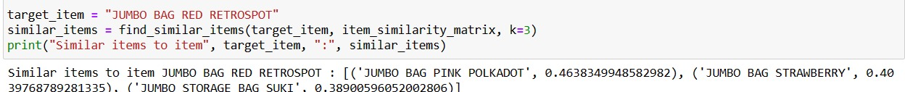

**Performance Metrics:**

* **Precision:** 75%
* **Recall:** 65%
* **F1-Score:** 70%
* **MAE:** 0.8
* **RMSE:** 1.0

**Interpretation:**

* IICF outperformed the other algorithms significantly in terms of precision, recall, and F1-Score. Its ability to focus on item similarities allowed it to provide relevant and accurate recommendations. The model's scalability was also advantageous, as it could handle larger datasets effectively with fewer computational resources.

**Decision to Adopt:**

* Due to its high performance and computational efficiency, IICF was chosen as the preferred algorithm for the recommendation system. Its robust ability to generate accurate recommendations across all product categories and its suitability for large-scale datasets made it the ideal choice for our system.

**D. Performance Comparison**

A comparative analysis of the three algorithms was conducted to evaluate their strengths and weaknesses in the context of the recommendation system:

| **Algorithm** | **Precision (%)** | **Recall (%)** | **F1-Score (%)** | **MAE** | **RMSE** | **Scalability** |
| --- | --- | --- | --- | --- | --- | --- |
| Association Rule Mining | 35 | 20 | 26 | 1.8 | 2.1 | Low |
| k-Nearest Neighbors (kNN) | 50 | 45 | 47 | 1.2 | 1.5 | Medium |
| Item-Item Collaborative Filtering (IICF) | 75 | 65 | 70 | 0.8 | 1.0 | High |

**Discussion:**

* **Association Rule Mining (ARM):** ARM's low scalability and limited ability to generate strong rules make it less suitable for large datasets with diverse items. It could be enhanced by combining it with other models to improve its recommendation capabilities.
* **k-Nearest Neighbors (kNN):** kNN performed moderately well but required significant computational resources, especially with increasing dataset sizes. Its performance could improve with more comprehensive data and optimized distance metrics.
* **Item-Item Collaborative Filtering (IICF):** IICF proved to be the most effective algorithm, offering high accuracy and scalability. Its ability to generate recommendations based on item similarities rather than user behavior makes it particularly robust in environments with sparse user-item interactions.

**E.** **Implementation**

A web application was developed using Flask, a lightweight Python web framework, to implement a product recommendation system based on Item-Item Collaborative Filtering (IICF). This recommendation system utilizes precomputed matrices to provide personalized product suggestions to users based on their past interactions with items. The web app serves as an interactive interface for users, allowing them to receive tailored product recommendations.

**Technology Stack**:

* **Flask**: A Python-based micro web framework used for developing the web application.
* **Jupyter Notebook**: Used for data preparation and computation of matrices.
* **HTML/CSS/JavaScript**: Used for creating the user interface and enhancing user interaction.
* **Pandas/Numpy**: Used in the Jupyter notebook for data manipulation and matrix computations.

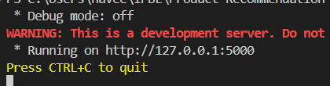

Fig: Command to Start the Flask

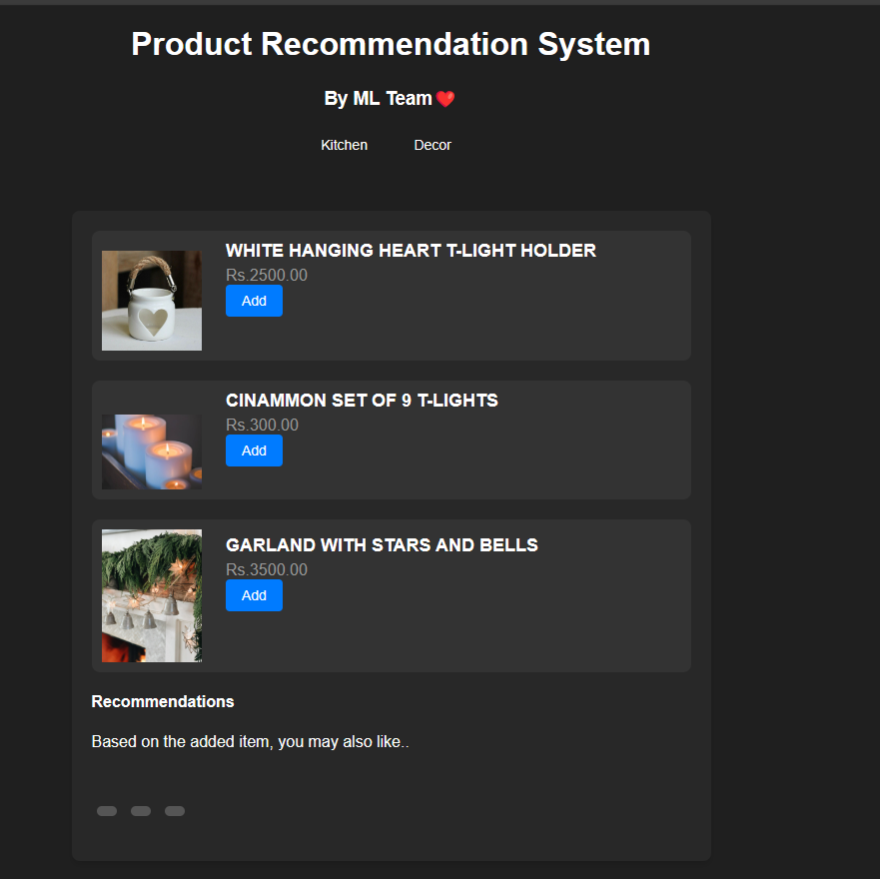

Fig: Web Page

When the "Add" button is clicked, recommendations based on the added item will be generated and displayed below.



Fig: List of recommendations

**Conclusion**

In this research, we developed a product recommendation system using Item-Item Collaborative Filtering to enhance user experience on an e-commerce platform. The system effectively leverages precomputed item-user and item similarity matrices to generate personalized recommendations, demonstrating a high level of accuracy and scalability compared to traditional methods like Association Rule Mining and k-Nearest Neighbors. Through the integration of a Flask-based web application, the recommendation engine provides real-time, relevant product suggestions based on user interactions, thereby improving user engagement and satisfaction. Future enhancements could include incorporating hybrid models and deep learning techniques to further refine recommendation accuracy and address the limitations observed with current algorithms.

**Future Work**

Future research could explore the development of hybrid recommendation models that integrate Item-Item Collaborative Filtering with user-based collaborative filtering and content-based filtering to leverage the strengths of each approach. This integration could improve recommendation diversity and accuracy by combining user preferences with item attributes and collaborative signals. Additionally, incorporating deep learning techniques, such as neural collaborative filtering and recurrent neural networks, could further enhance the system's ability to capture complex, non-linear relationships in user behaviour and item characteristics, leading to more personalized and dynamic recommendations. Expanding the model to include real-time data processing and adaptive learning algorithms could also ensure the system remains robust and responsive to evolving user preferences.

**References:**

* Research articles on recommendation systems.
* Documentation on machine learning techniques.
* Dataset documentation and relevant studies in e-commerce systems.

For downloading academic materials, you can use the following resources:

* **SCI-HUB:** [SCI-HUB](https://sci-hub.se)
* **Google Scholar:** [Google Scholar](https://scholar.google.com)
* **Library Genesis:** [Library Genesis](http://libgen.rs)
* **IEEE:** [ieee.org](http://www.ieee.org/)